## Iteration 1:

### Settings page:

#### **A screenshot of a computer Description automatically generatedL**ayout:

I created a new view controller and added a name, age, weight, height and gender input boxes. Then i added these to my code so that you can create a variable from the text in the input boxes. Then I add a button which will run the save function

Validation

I need to make it so that The user can pick between male or female for genders. This is because it needs to be in the correct format for when I use if statements later on in the code which require either Male or Female to run. I can do this by using a picker view which will allow the user to select what gender they are.

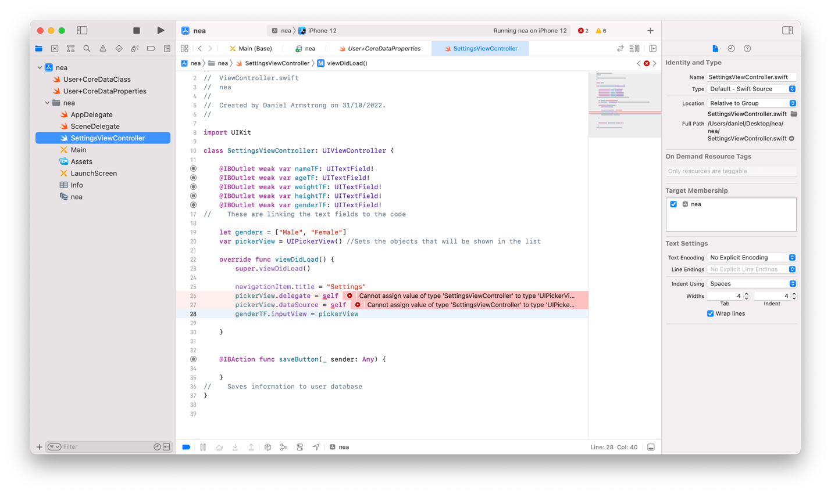

I created an array with the items Male and Female. Then I created a picker view for the gender text input, ‘genderTF’. After this I had two errors saying I didn’t have the correct ui type for a picker view.

Fix error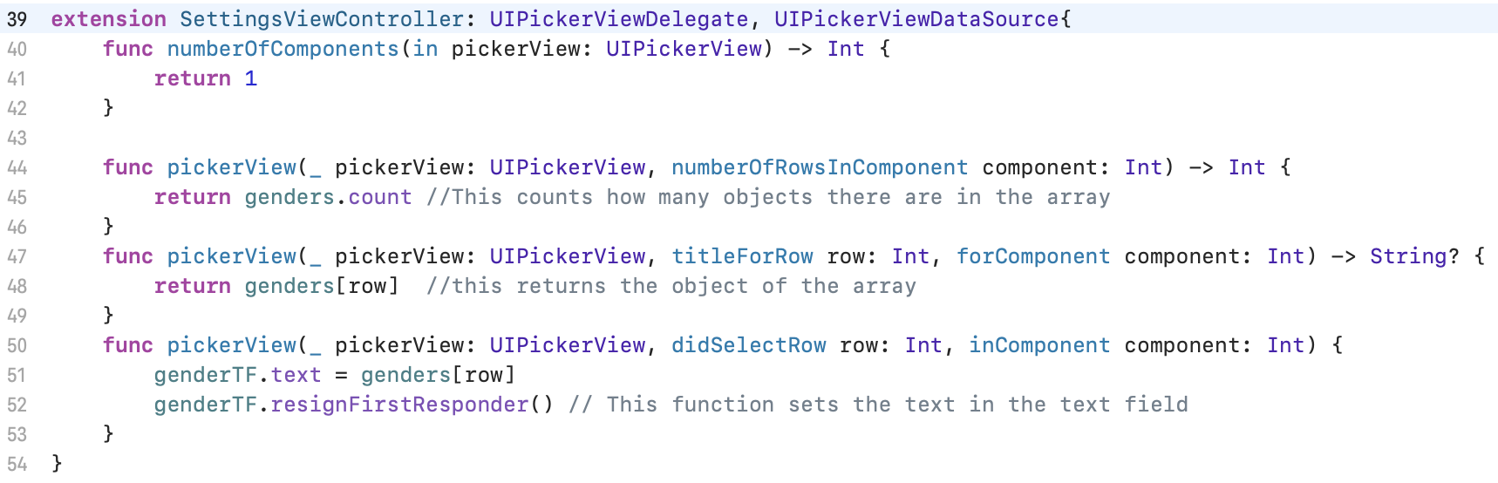

To fix this error I created an extension to my view controller with type UIPickerViewDelegate and UiPickerViewDatasource. This is so that it can show a small overlay with the items the user can select from. I created a function which counts the number of objects there are in the variable so it knows how many rows to put in the picker view. Then I created a function which puts the objects from the array into the picker view. Then the final function sets the text in the text field to what the user selects in the picker view. Then the item from the gender text field can be saved in a variable.

**Play video 1**

Number pad

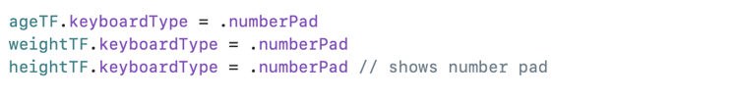Then I had to make it so that the user can only input an integer for age, weight and height. To do this I will make it so that when the user presses on the input box a number pad shows up instead of a full keyboard, so they can't enter letter and symbols. This code sets the type of keyboard to appear on these text fields.

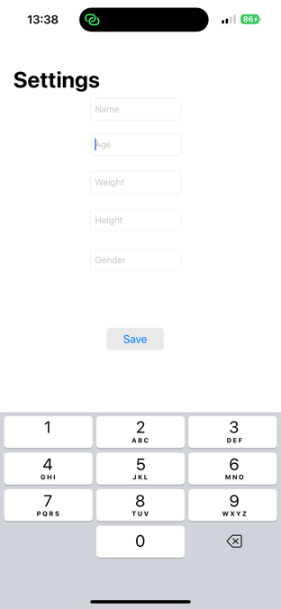This is what shows up when the user presses on the age text field.

### Calculating BMR

Now I have to write the function to get the text from the text fields and use it to calculate what the users bmr will be. This is a vital part of my application as everything is based around the amount of calories the user is burning.

First I will add the equation just for if male is selected as the gender from the gender picker view

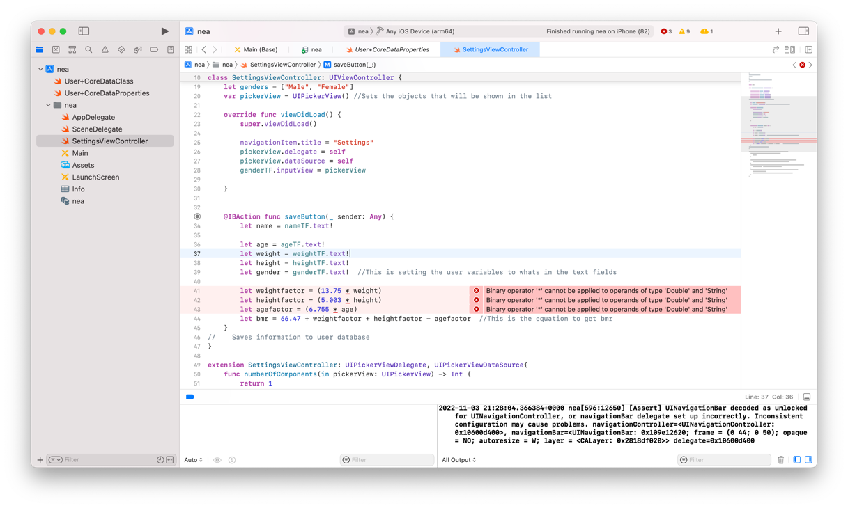

Firstly I set a variable to each of the text fields to get the text that the user had inputted. Then I tried to use these variables to work out the users bmr, but I had a build error. This was because even though numbers had been entered in to the text fields they were still being stored as a string but I needed them to be a float value to use for calculating bmr.

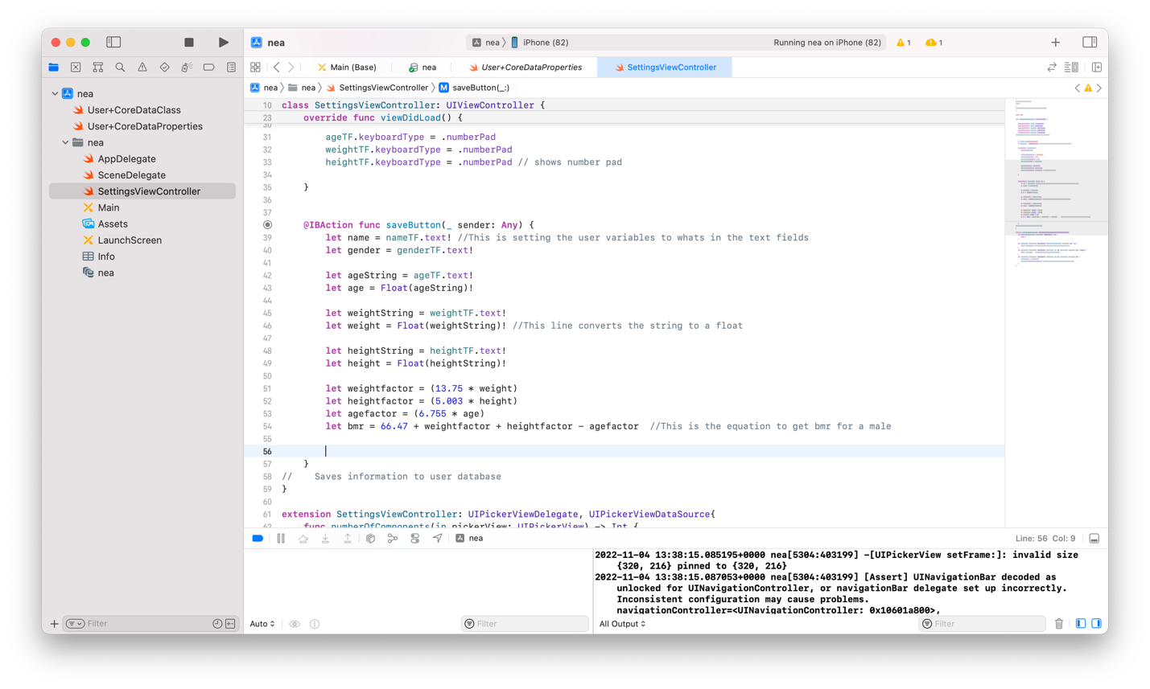This is the code to fix the error:

This converts the string value received from the text field into Fload variables which can be used in the bmr calculation.

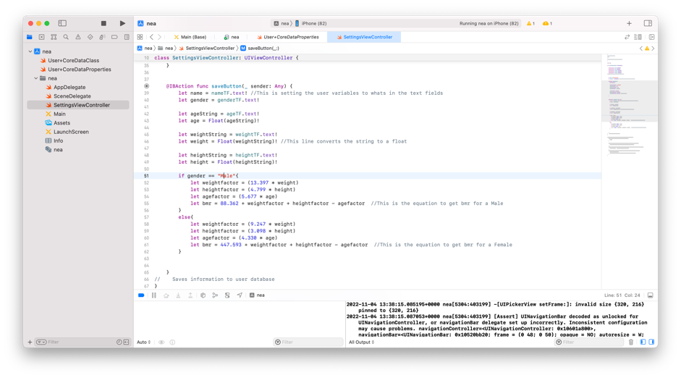

Now I have added an if statement to the code so that if the user selects the gender as male it wil run the equation for a male but if they put female it will run the equation to work out the bmr for a female. This is a necessary feature as men and women burn different amounts of calories at rest so if this is not the bmr calculation would be innacrrate

#### testing

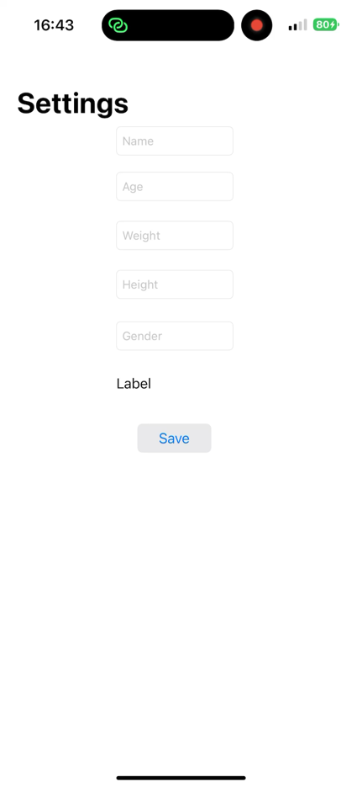

**Test Table**

|  |  |  |  |
| --- | --- | --- | --- |
| **Inputs** | **Process** | **Expected output** | **Actual Output** |
| Age: 17  Weight: 75  Height: 175  Gender: Male | 88.362 + (13.397*75) +(4.799*175)-(5.677*17) | 1836.453 |  |
| Age: 20  Weight: 55  Height: 160  Gender: Female | 447.593 + 9.247 * 55 + 3.098 * 160 – 4.330*20 | 1365.258 |  |

### A screenshot of a computer Description automatically generatedCreating user database

This part is not documented as I change to user defaults later in my project.

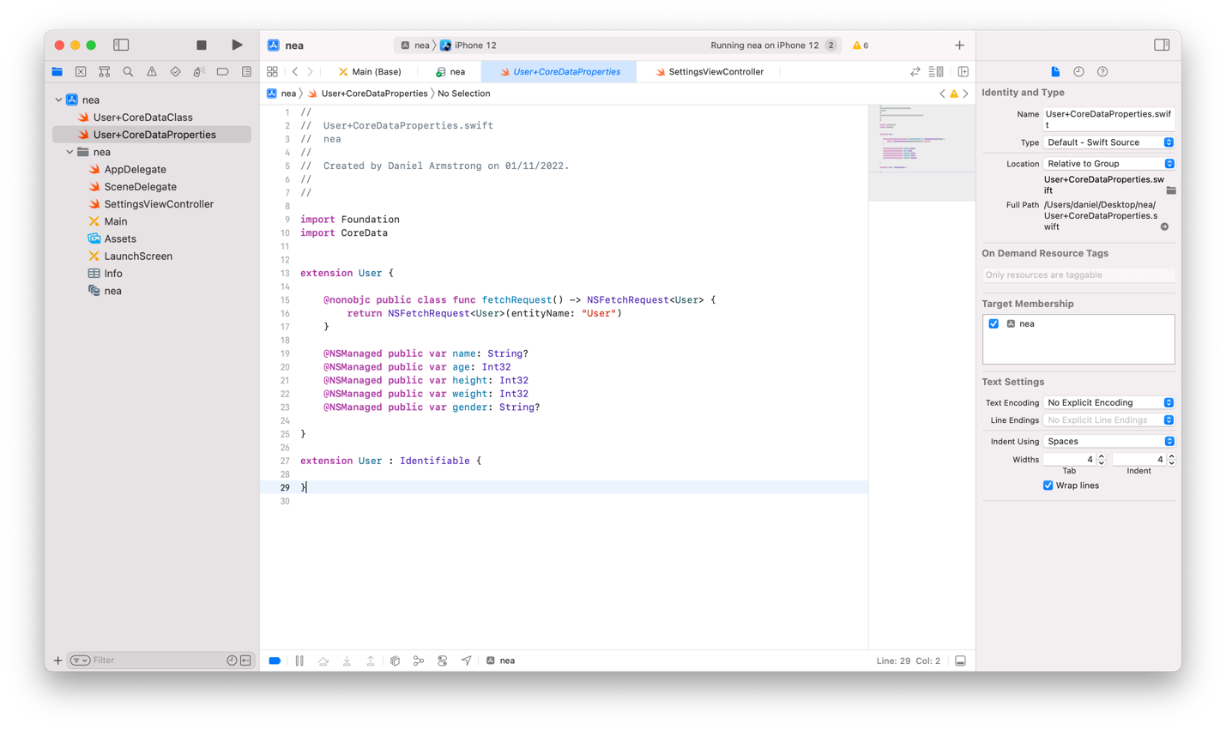

### Graphical user interface, text, application Description automatically generatedGraphical user interface, text, application Description automatically generatedsaving to user database

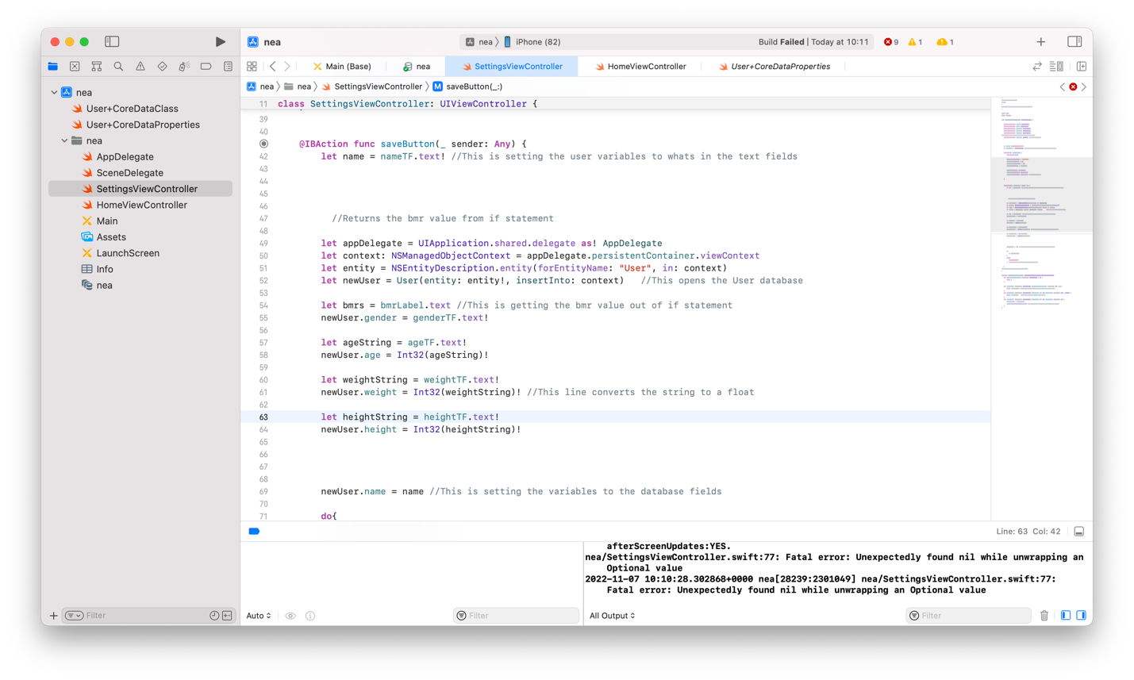

### Retrieving from User database

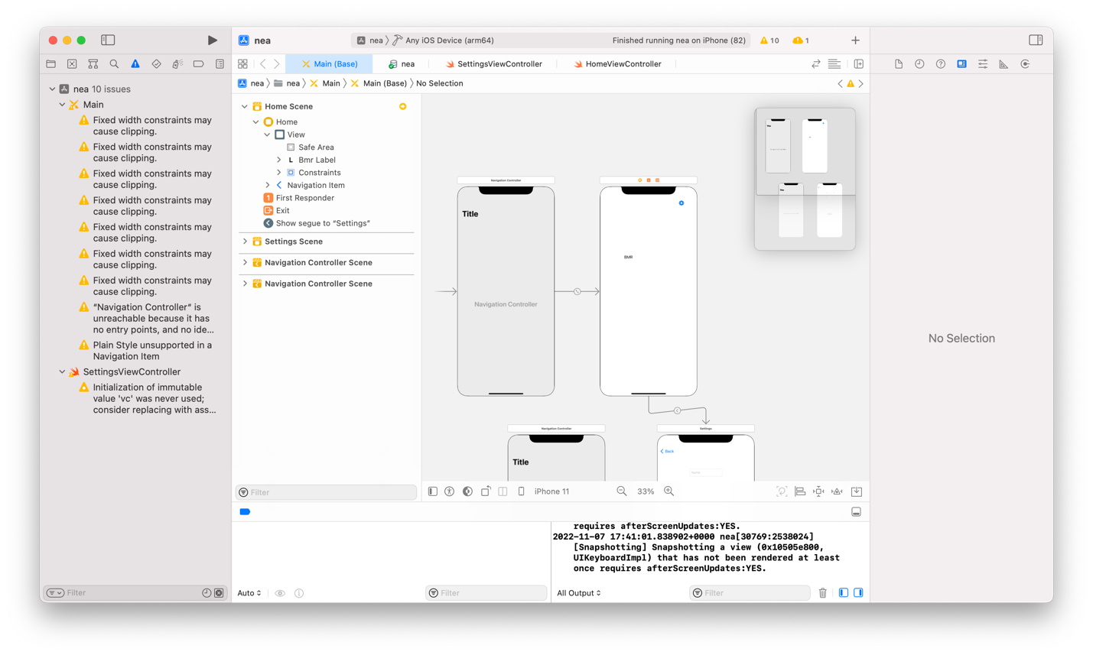

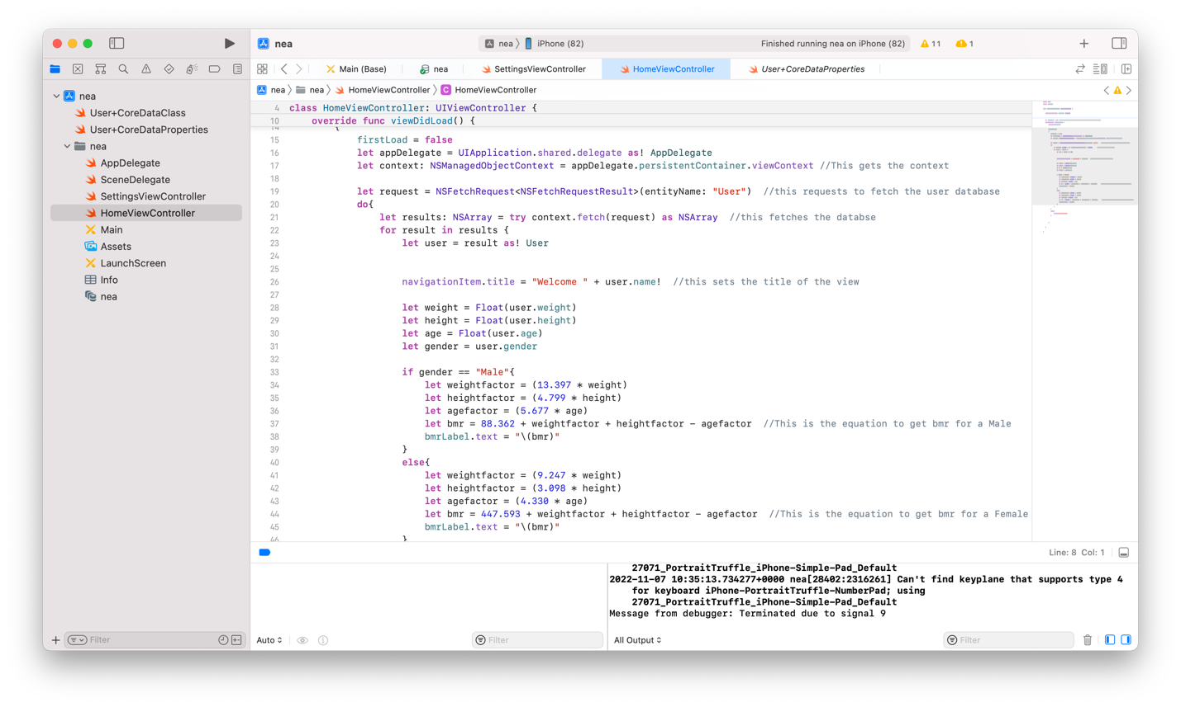

### Changing to user defaults

I discovered that saving the users information to app storage would be more efficient. I have done this by using User Defaults. This is more efficient because their will only ever be one user using the app at a time since it is only stored locally. A database would keep creating record if something is changed but by using app storage it just stores it as a single variable. It does this by setting a temporary variable to the users information then setting a user default with a key which matches the variable. This is done so that the key can be called after the app is closed and reopened.

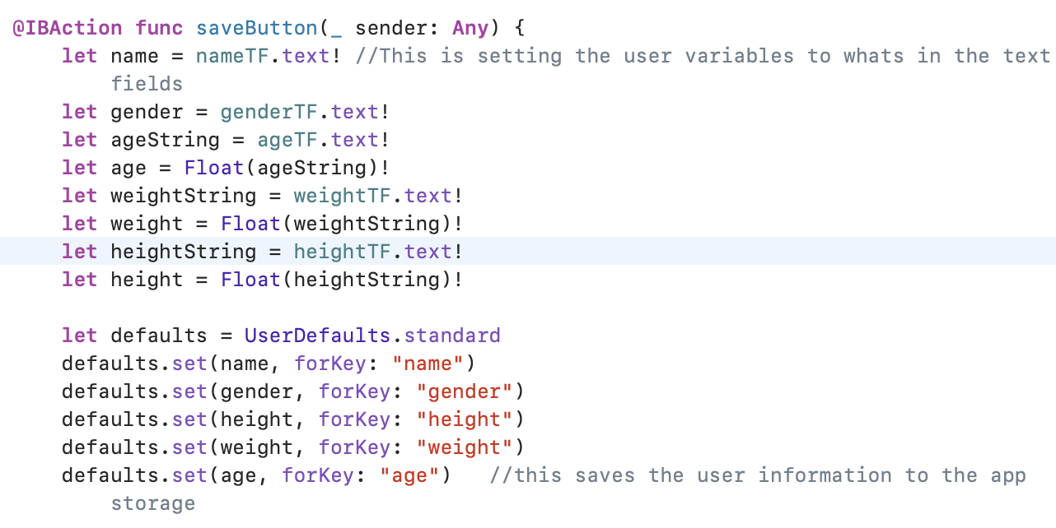Firstly I deleted the user database. Then after I had created a variable from the information in the text field, I set a variable called defaults to UserDefaults.standard. This is a function which saves a variable to the app storage. Then I used defaults.set(name forkey: “name”). sets the name variable to the name key which will then be saved within the app storage so that the user can go off the app and when they come back it will still be saved within the app storage so the variable can still be used. Then I used this same line of code for each variable of the user information saving it in a key with the same name as the variable. This also means these variables can be accessed from any screen in the application.

### creating homescreen



Firstly, I created a new View controller called HomeViewController and also created a new class with the same name and made it type UIViewController so that I could connect it to the home screen view controller. Then I created a button with one of the system items that are in the ide to make a settings button. Then I created a segue from the settings button to the settings page, so that it will show then the button is pressed.

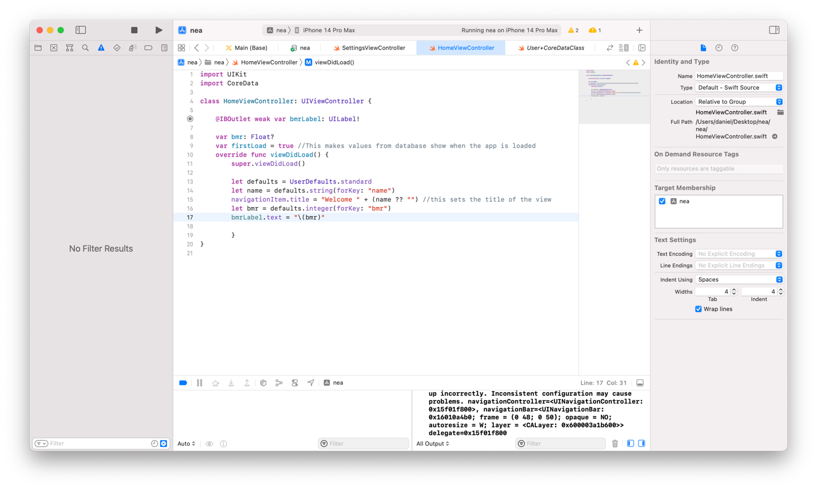

#### testing bmr

Watch video 2

This shows that the bmr is being calculated as expected

### create algorithm to get steps

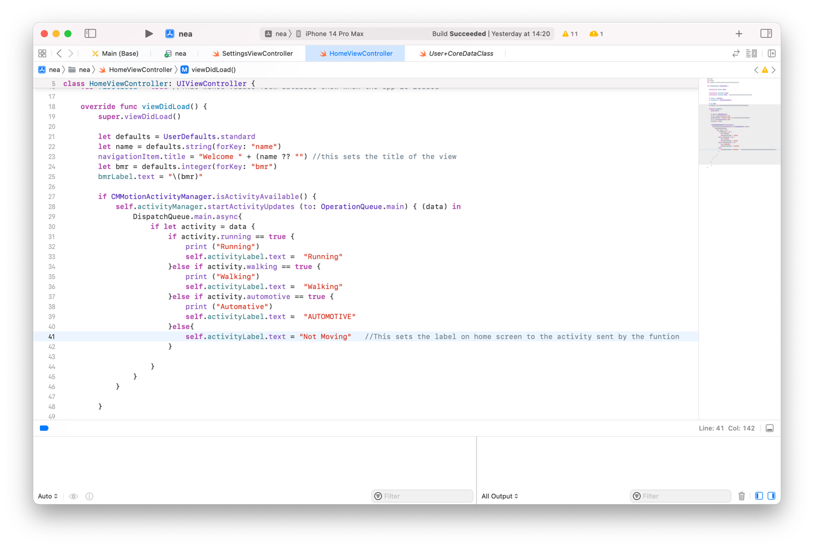

This is the piece of code used for getting what activity type the user is doing. It uses a function called CMMotionActivityManager. First it starts activity updates using the acitivty manager. Then it checks a range of acivities the user could be doing. Ive made it so that whatever acivity the user is doing it will print this to the console which will be useful for testing. I have also created an activity label to display this by using self.activityLabel.text.

This is a required part of my project so that it can auomatically detect exercise like walking and running so that the users calories can be acuratly calculated.

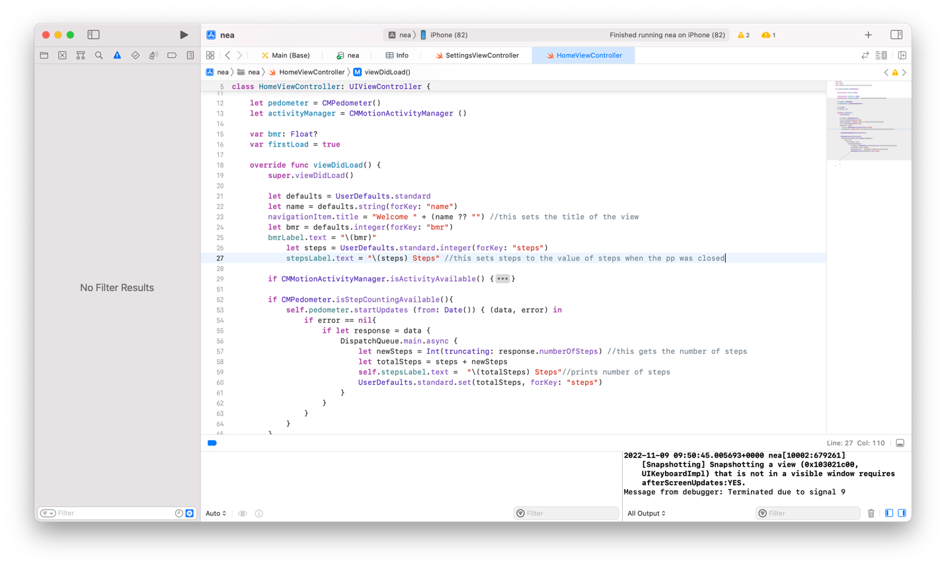Next I need to create a function to get step data

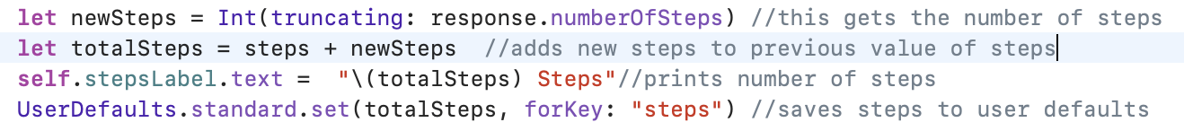This is the function to get steps. First it checks if CMPedometer is available which it will be if the user gives the app permission to do this. Then it starts updating the function.

This gets the value of steps from the step counter function and adds the steps while the app has been running to the value of steps when the app was last closed. Then if the app is closed it will save this value to the app storage using user defaults. Which will be taken out of user defaults to a variable when the app is opened

#### add calories from steps to calorie value

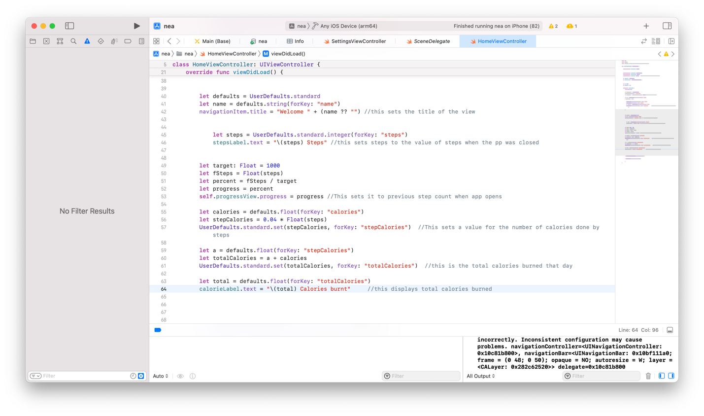

This part of the code first gets the current value of calories which is stored in user defaults with the key ‘calories’. Then it calculates step calories by doing steps * 0.04 and steps has to be a float value to do this calculation otherwise there will be an error since they need to be the same data type.

Then is saves step calories to user defaults for if it needs to be used later.

Then it adds step calories to calories and sets it to the variable totalCalories and saves this into user defaults with the key “totalCalories”. Then it displays this onto the home screen calorie label using string interpolation. This is necessary since you cant just assign a float value to a text label it has to be in string data type

#### Setting target and progress bar

I will set the target steps to a fixed value of 10,000 steps a day but I might change this later in my code to recommend different step targets depending on the users age and gender. This step target is then used to work out a percentage of the steps they have done out of the goal and then displays this on a progress bar.

**For testing I set the target value to 1000 so that I could see the progress bar moving without having to take a lot of steps.**

This is the code to work display the percentage on a progress bar:

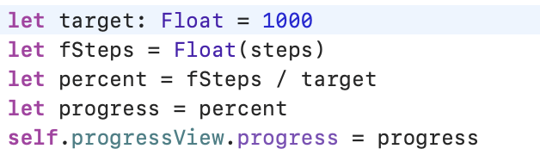

Then this line of code is at the start to create the progress view item:



#### Testing

I took 63 steps. The result of this should be to display 63 steps and the calorie value should be bmr + (0.04 * steps taken). The BMR value is set to 1836. The output for calories burned should equal 1836 + (0.04*63) = 1838.52

Screenshot of output:

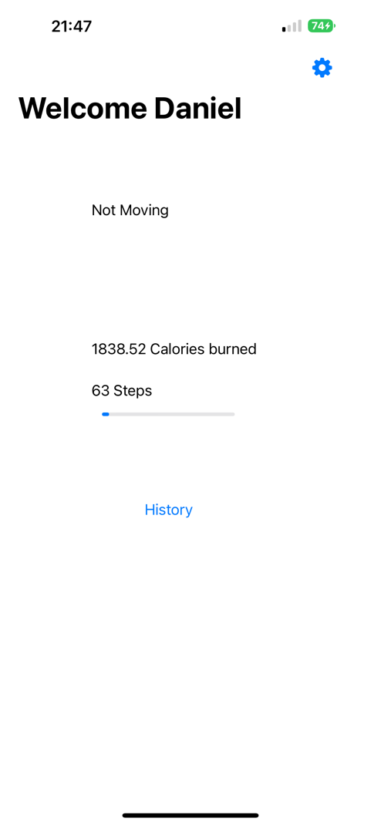

### Creating history database

I will need to create a database using core data which will be used to store the users steps and calories at the end of the day so that they are able to go back and see the amount of steps and calories done each day. I first created the history database by using the core data feature that is in xcode.

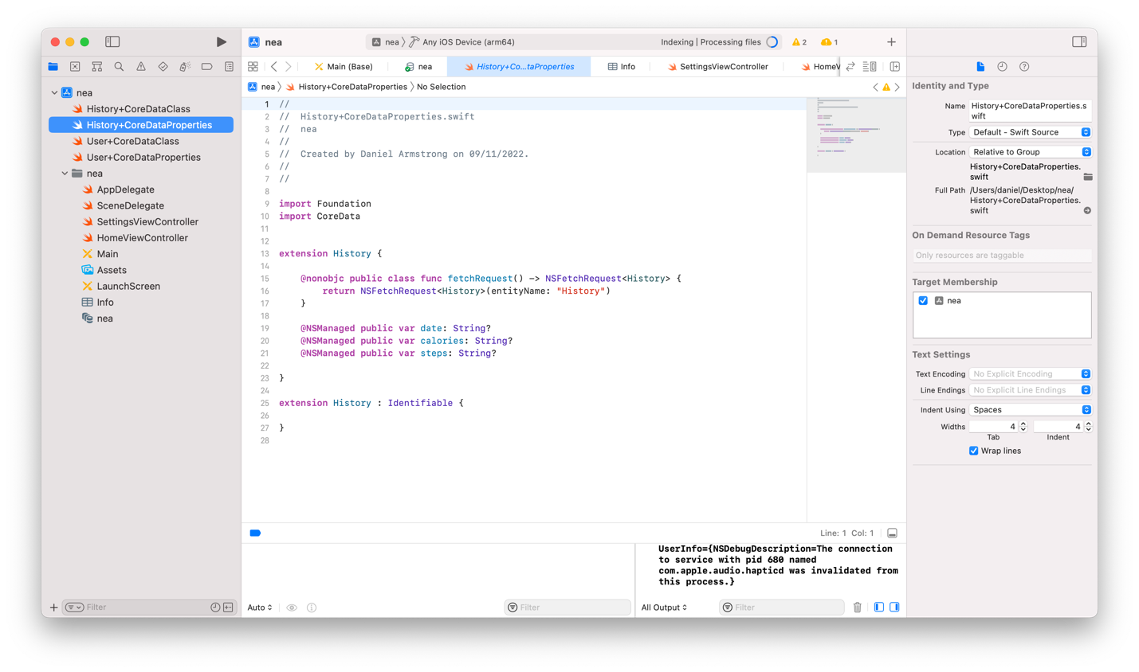

The after I created it and added the necessary fields it created 2 files. History CoreDataClass and History CoreDataProperties.

CoreDataProperties is used to define what fields needs to be in the database and what type they are. For this case all of the fields need to be of string data type. I also need to add an extention and make this file identifiable so that I can access the database in other parts of my code when I request it.

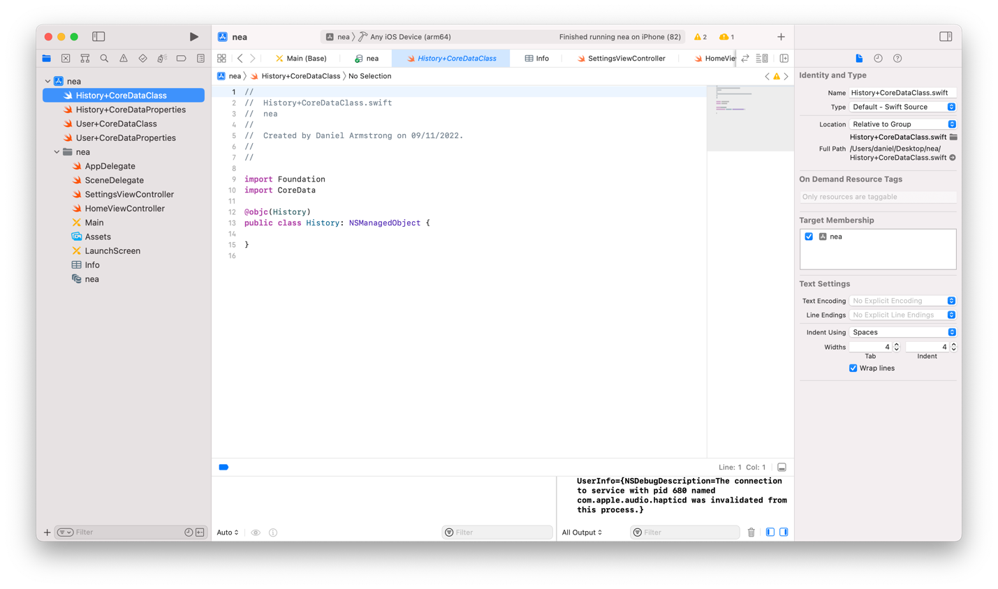

CoreDataClass is necessary for created the object History and class History. It makes this class type NSManagedObject this is necessary to use this object in other parts of my code. Which I will need to do to access the history database on the history table view.

#### save current steps and calories at midnight

Firstly I need to get the current date and then save it. This is so that when the application opens it can check the current date to the previous date and if they are different then it must be a new day so it will run the save function.

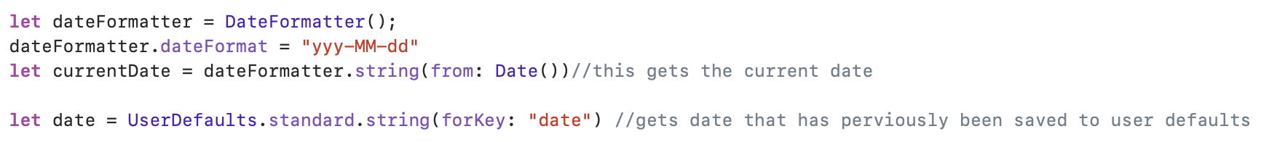

This first creates a new instance of DateFormatter and is assigned to the constant dateFormatter. The dateFormat property of the dateFormatter object is set to "yyy-MM-dd", which represents the format of the date string that will be generated.

Then the previously saved date value is retrieved from UserDefaults and assigned to the constant date. The value is retrieved using the string(forKey:) method of UserDefaults and passing in the key "date" as the parameter. If the key does not exist or the value associated with the key is not a string, then the string(forKey:) method will return nil.

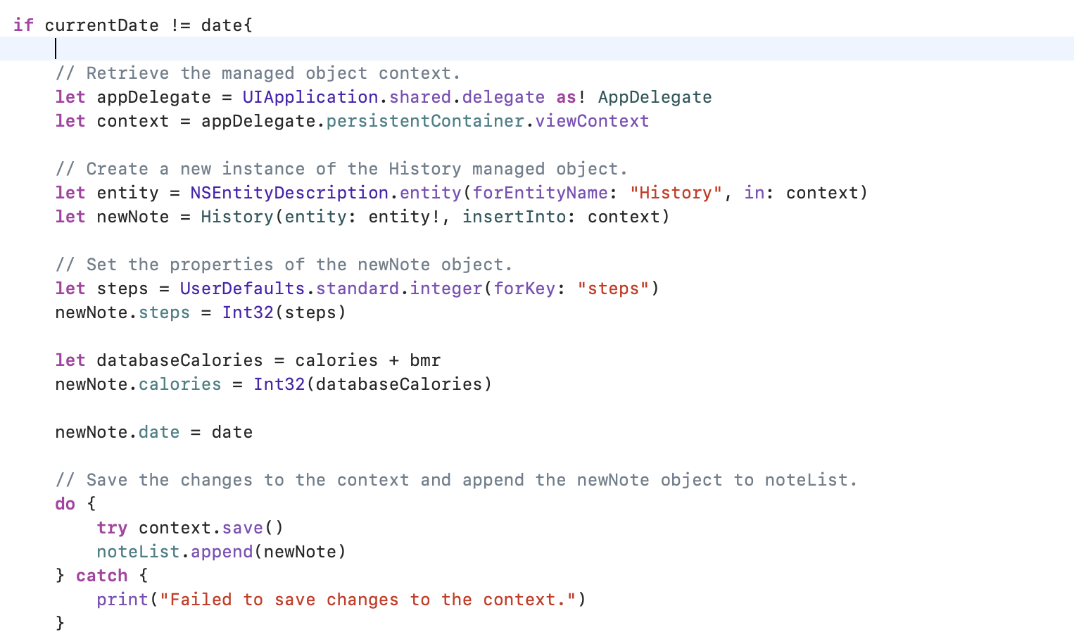

This code checks whether the current date is different from the date that was previously saved in the user defaults. If the dates differ, a new instance of the History managed object is created and used to store the user's activity data. It then sets the properties of the History object using data from UserDefaults and other variables, such as the number of steps taken and calories burned by the user. Finally, the changes are saved to the managed object context, and the new History object is appended to an array called noteList. If an error occurs during the save process, an error message is printed to the console.

The programme will always save the most recent activity data for the user if the function is run daily. The user's activity level can vary from day to day, so it's critical to precisely record that data in order to give the user an accurate picture of their activity over time.

#### resetting steps and calories for a new day

I will add code onto the if statement which will mean it will reset if the current date is not equal to the date saved.

This is the code which I wrote:

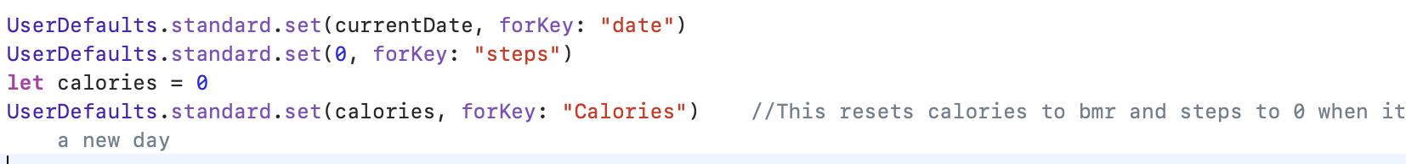

At the beginning of each day, the above code refreshes the user's values for steps and calories. It accomplishes this by first utilising the set( :forKey:) function to set the value of the "date" key in user defaults to the current date. The "steps" key's value is then set to 0 using the same approach. Lastly, it sets the value of the "Calories" key to a new variable called "calories" that has a value of 0. By doing this, you can make sure that the calorie count for each day begins at 0 and does not carry over from the previous day's total. This code block is crucial overall for making sure that the my app correctly records the user's activity information for each new day.

#### Display calories and steps history

Firstly I created a table view which will show all of the previous days.

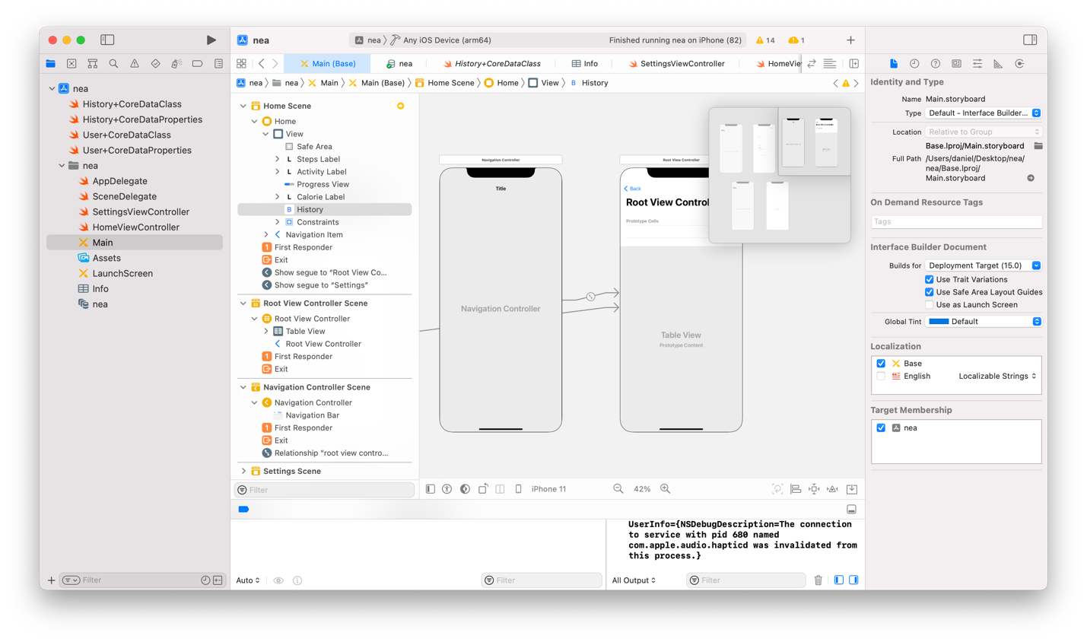

Then I created a prototype cell and added labels for the date, steps and calories burned. This will be used to display each record in the history database in the same format .

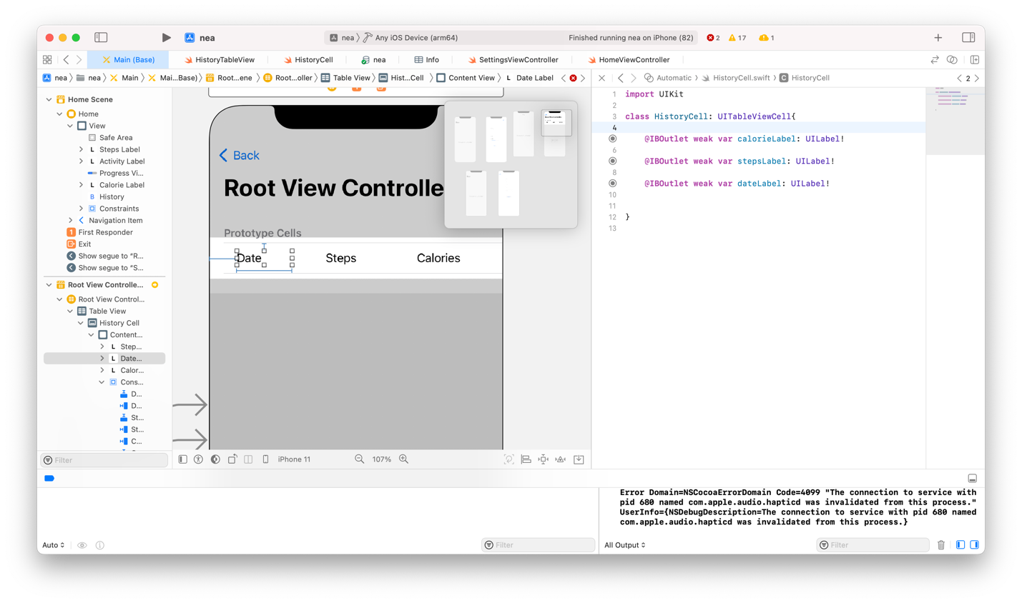

#### Loading History database

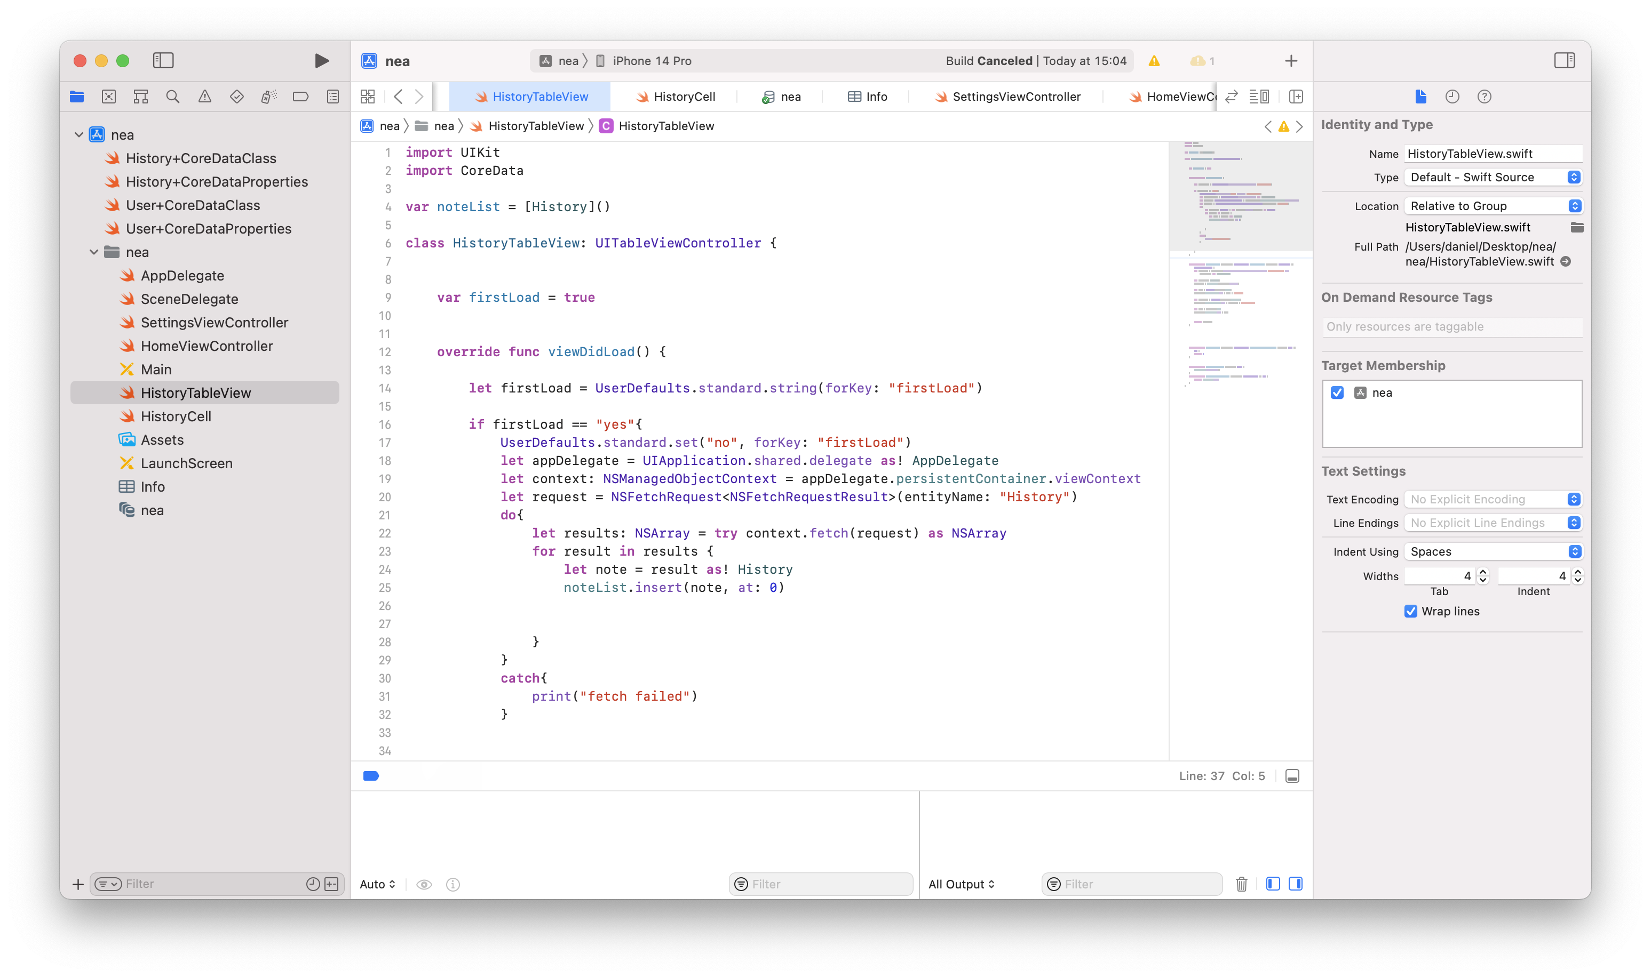

This will load this when the app is first opened by using the if statement with first load. If does run it will set first load to no so that it doesn’t keep running and making duplicates of the data on the table view which is what would happen if this. If statement wasn’t there. Then it needs to get the app delegate and context which is necessary to read the database.

After it has done this it can create a request to get the database information use the NSFetch request function with the entity history. So that it will fetch the history database.

Then after it has done this it will run a for loop to get each record in the database. Each time this for loop runs it will create a note with this result and then add this note to note list. This will be used when putting all the record onto the history table view.

This is all in a do catch statement so that if there is an error with retrieving the database it will catch the error and display print error so the app wont crash.

#### displaying each record as a cell

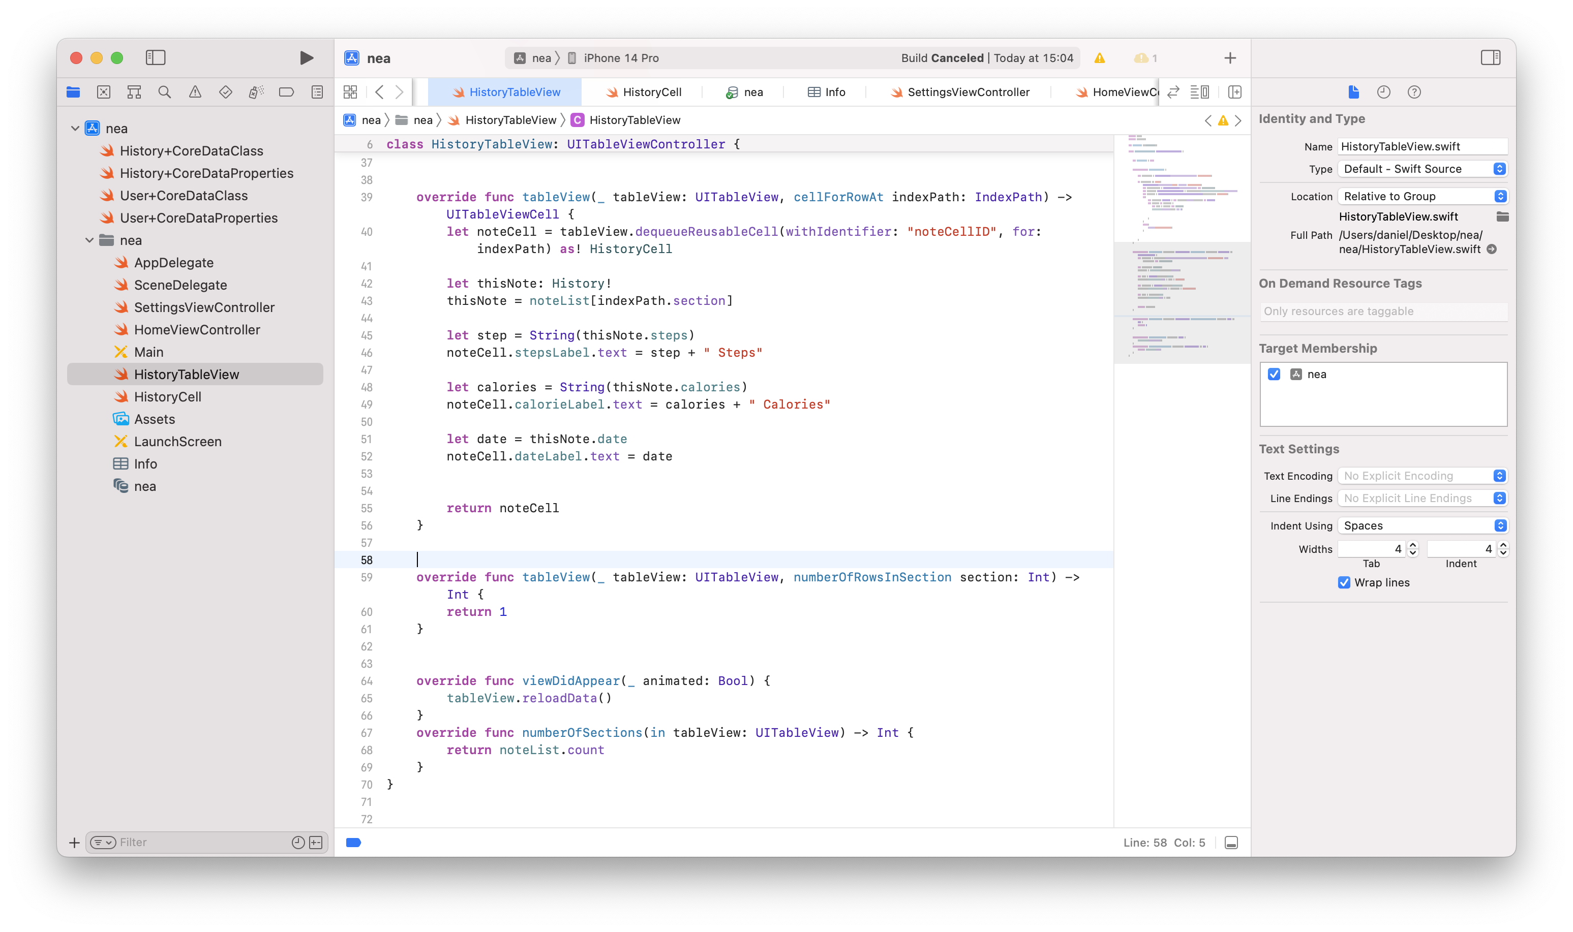

This function is necessary to display each record in the cell. It first starts a tableView function with type UITableView which will run this function for every row in the table view.

In this functionion it first lests noteCell equal to the cell ID. This is so that the cell can be written to.

Then it gets a record from the History database and the assigns it to this note. This is so that the data can be got out of each note.

Then it sets steps to thisNote.steps. this gets the steps data out of the current record. Then it assigns this data to notecell.stepsLabel. This has to be used to specify that the label is in the noteCell. Then it does the same thing for calories and date then returns the noteCell to the History table View.

Then It will repeat this function to get the next item in the noteList to get the next record in the database and it will return the next cell. It will do this for all the records in the database

### Complete iteration 1

Watch video 3

### Stakeholder input

Waleed has said that it would be better if there weren’t any decimal places with the calorie value on the homescreen. He has also said the ui should be easier to read.

### Settings page error

After doing stakeholder input it realised my settings page had a bug. If the user wanted to change one bit of there information, for example change their height from 175 to 180, if they left the other text fields blank it would quit the app. Watch settings error video.

#### solution

In order to fix this error I will make it so that the users information stays in the settings text fields so that if they only want to change one piece of information all of their other information will still be there so when the user presses save there will be no blank text fields.

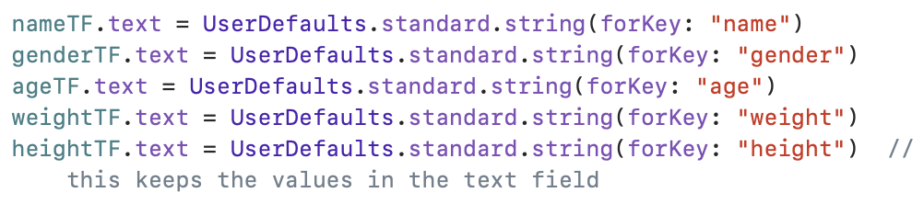

This code sets the text in the text field to the information stored in the app storage. It does this by using the user defaults function and getting the information in the key which correlates to the text field.

Watch settings page solution video.

### steps error

Whilst using my app I noticed that when I was being driven in the car, the activity which was being show was automotive which is correct, But it was noticing bumps in the road and registering them as steps. So the steps value was increasing even though no steps were being taken, this would lead to an inaccurate reading of steps at the end of the day. This would also cause the calories value to be inaccurate as calories are based of steps taken.

Watch steps error video, this shows that even though automotive is being shown the steps value is increasing

#### solution

To fix this I will need to put the steps algorithm into an if statement so that it wont run if activity type is automotive.

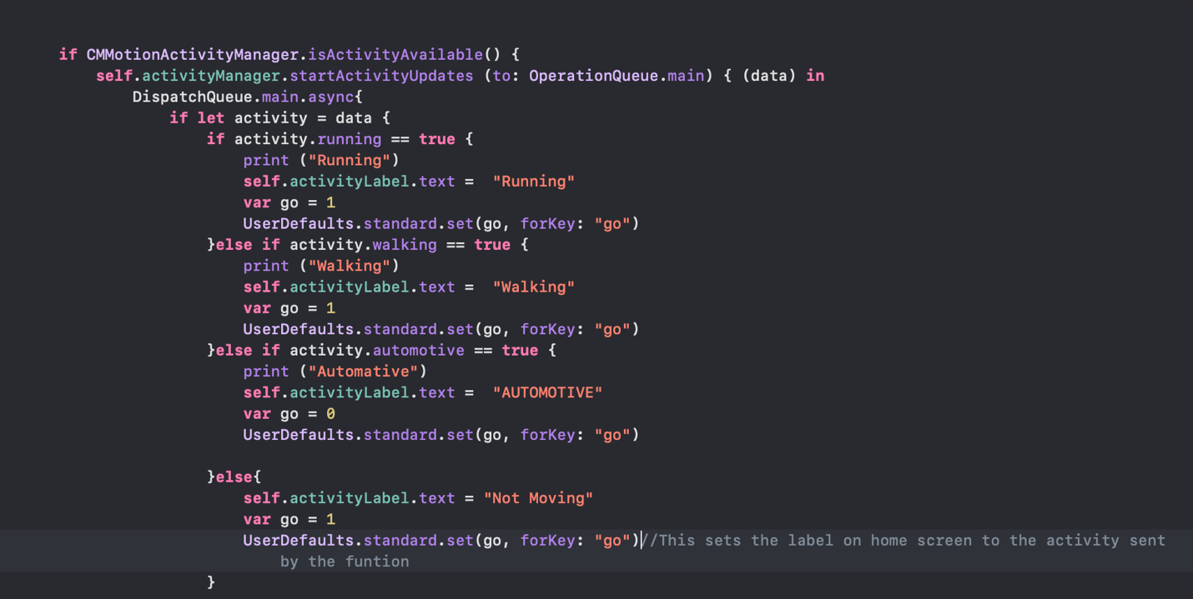

First I created a variable called go. I set it to 0 if activity = automotive and 1 if the activity is anything else. I decided to set it to 1 even if activity is not moving this is so that if it hasn’t registered any activity it can still track steps. Then I created a user default and stored the go variable into it. This is so that the variable can be used globally which it will need to be when used in a separate function which is the steps function. I also haad to put it after each activity type because the activity function is continuously checking the activity type so it will keep checking if automotive is activity type. If its not it needs to immediately start tracking steps again so that no steps are missed.

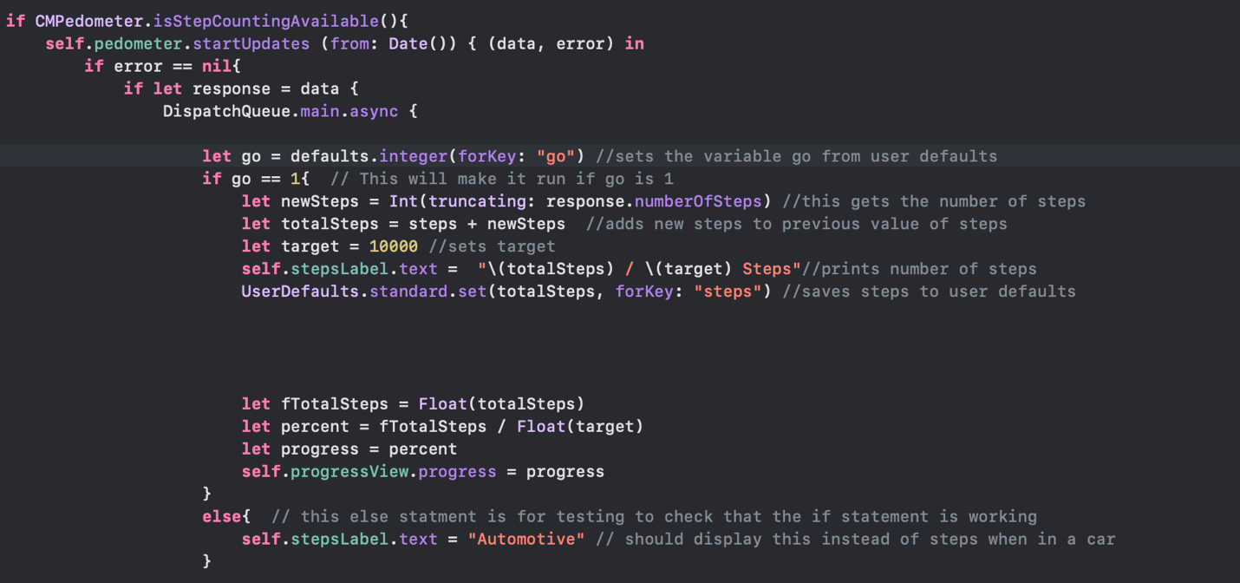

This si the new steps algorithm. First it will check for new steps being taken but before it adds the steps value, I have added a new if statemtn which checks the value of go. Firstly it gets the value from user defaults with key go and sets it to the variable go. Then if it is 1 (which it should be if not in a car) it will run the steps algorithm as normal and add steps to the steps variable.

However if go is 0, which will happen if automotive is true, it wont run the part of the algorithm which adds the new steps to the steps value. To check this is working I added a line of code to set the steps label to ‘automotive’ instead of displaying steps.

#### testing

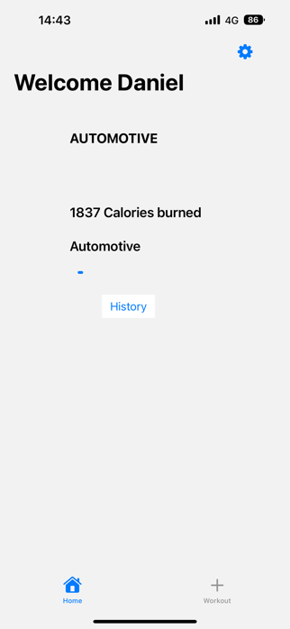 I went in the car and when there was a bump in the road which would’ve registered as a step before, it didn’t add this step to the steps value. Instead it displayed Automotive which shows the algorithm is working correctly. Then when I took a step outside when activity was walking, go was 0, so the steps label changed back to showing steps and added the new steps.